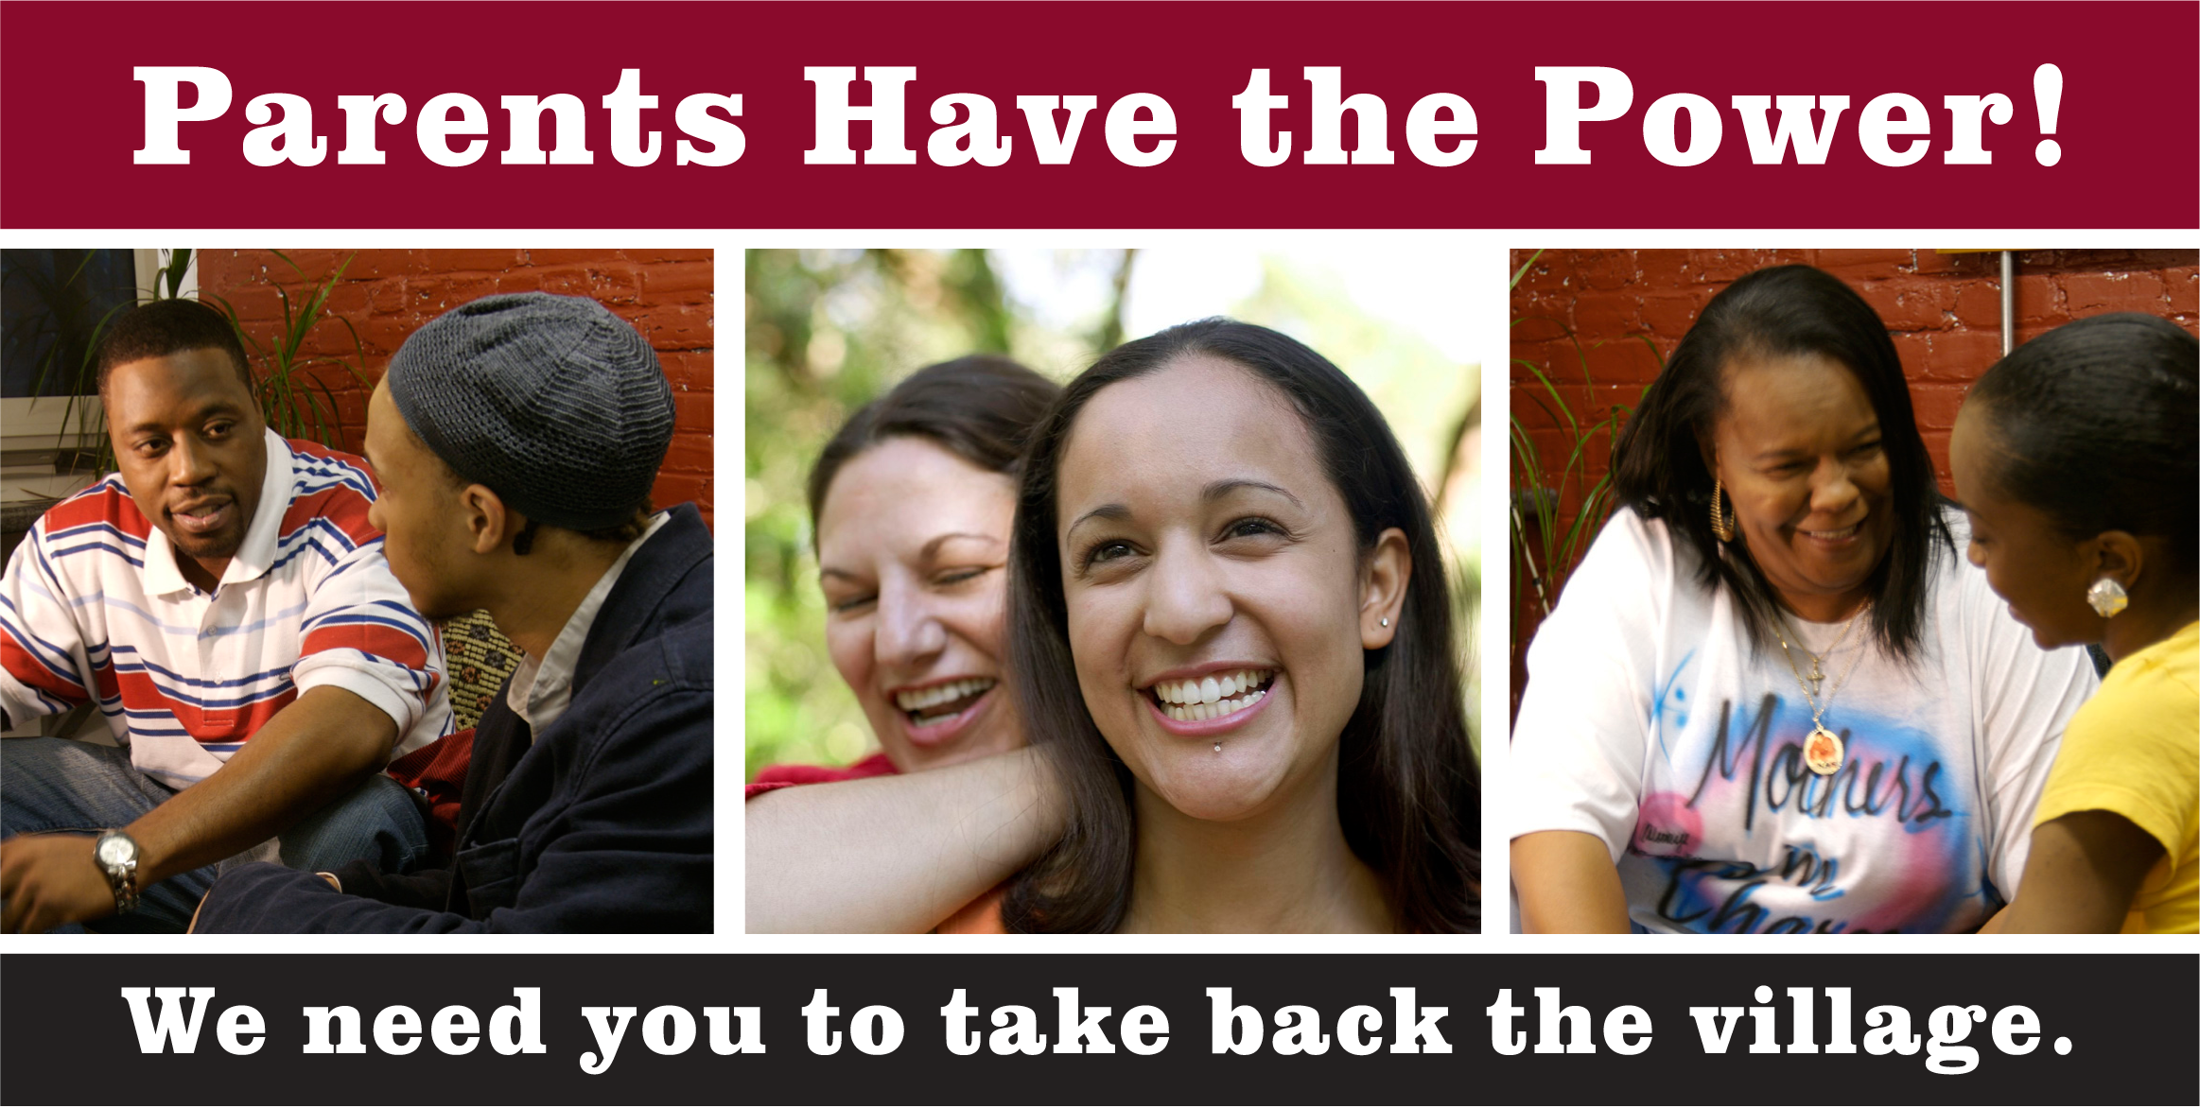

WWe want you!!!

Do you reside in

**ENGLEWOOD?**

Do you live in 60621 or 60636?

**RSVP IS Mandatory**

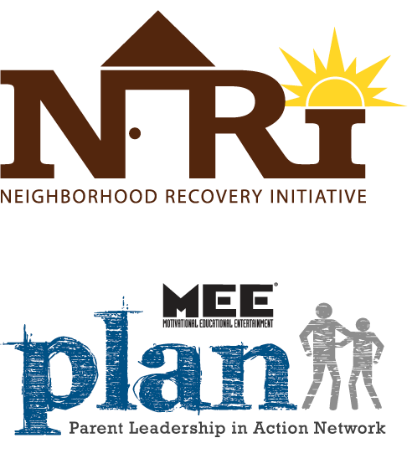

**Orientation will be held at:**

Children's Home + Aid

5958 S Marshfield Ave

Chicago, IL 60636

**Friday, May 18, 2012**

**Time:12:00noon-2pm**

**You must RSVP & PLAN TO COME ON TIME!**



**RSVP**

**A Knock At Midnight**

**400 W. 76th St. Ste 206**

**Office: 773-488-2960**

**Fax: 773-488-2020**

**Be a member of the Parent Leadership in Action Network (PLAN), and help us regain a strengthened sense of village. Come learn more!**

**If you are a Parent, Grandparent or relative who has gone “through the fire” and**

**can share your story with other parents to motivate them to do the same…**

**We WANT to HIRE you!**

**You will become a part of the Governor’s Neighborhood Recovery Initiative (NRI), a comprehensive effort to reduce youth violence and increase adult engagement and leadership. If you are a Chicago-area parent who is successfully raising or has recently raised an adolescent and you are willing to:**

* Share your “through the fire” story
* Attend all mandatory trainings
* Learn about issues facing other parents in your neighborhood—and local resources to deal with them
* Assist struggling parents raising youth ages 12-17 with violent prevention strategies
* Show up ready to serve on evenings and weekends

**We will:**

* Train you
* Pay you
* Prepare you to reclaim the village that can help SAVE our YOUTH from the streets by surrounding them with caring adults!